This is the weather app with minimal functionalities given in the vue.js 201 course procedure.

**Home Page :**

User can enter city names in the search bar and get weather

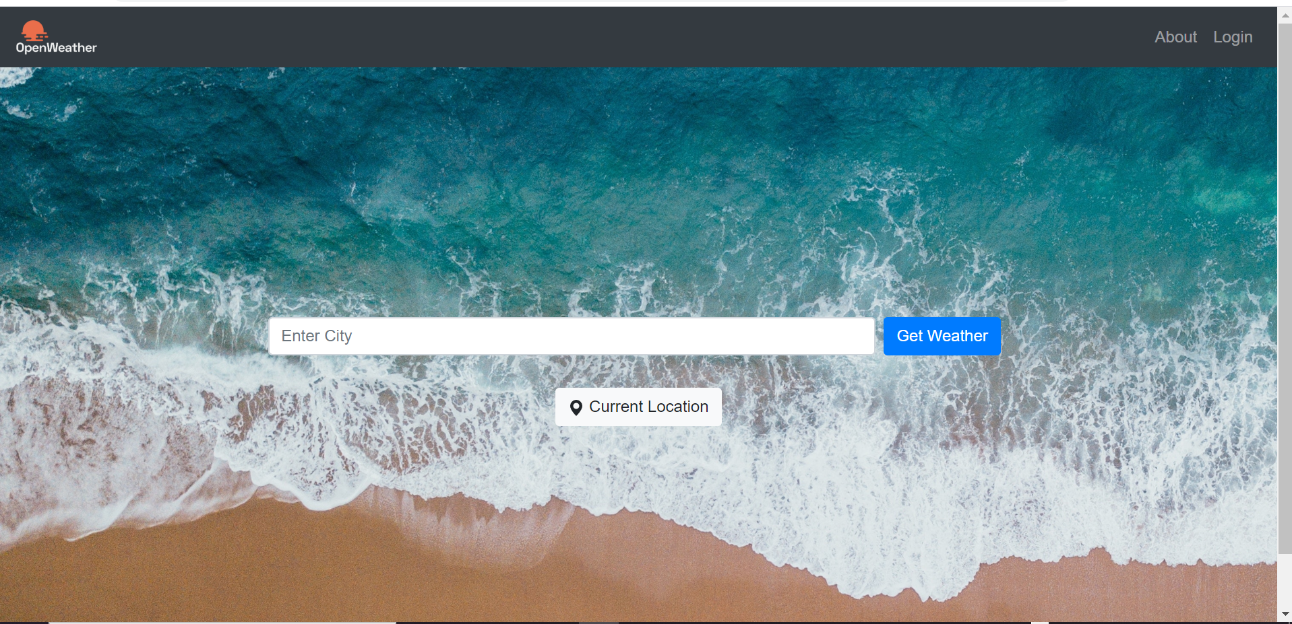

Auto suggestions for the cities are limited as the cities data is being read from a json file.

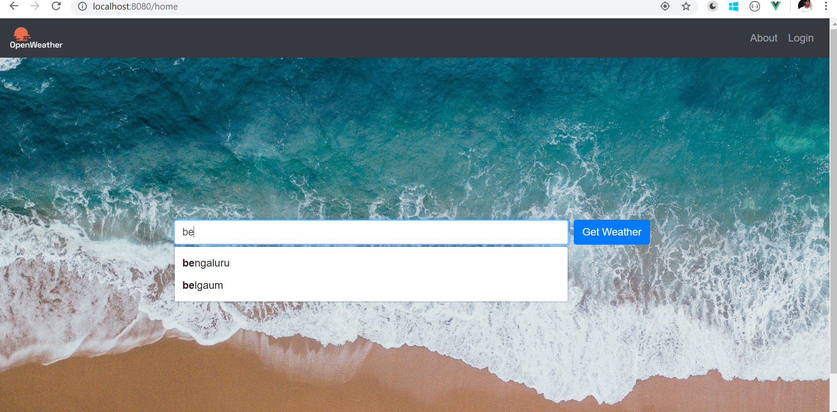

**Weather Details:**

User can search different cities weather or access their current location weather. Please note that the user can view weather details despite of login

**Note**: Geolocation feature will be unavailable if the if we run the app on dev server as the browsers needs secure connections like https to get current location.

Also note that current location will be cached for 10 seconds using localstorage for a demo purpose.

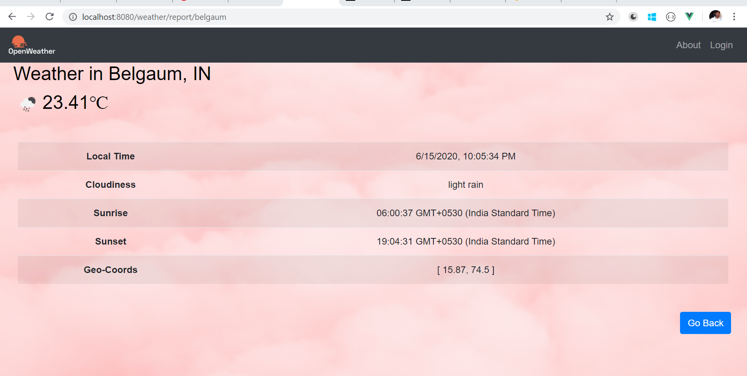

**Login Page:**

User can login into the application to save the locations or to view user’s saved locations . Here the user credentials are hardcoded for login purpose :

User-1 User-2

……………………… ……………………………

Username: hero Username: villain

Password: 1234 password: 1234

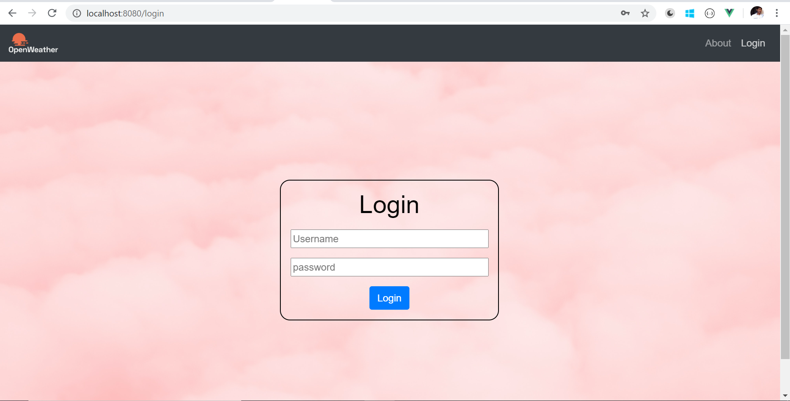

After user logged in :

Please note in the nav bar for the user specific saved locations

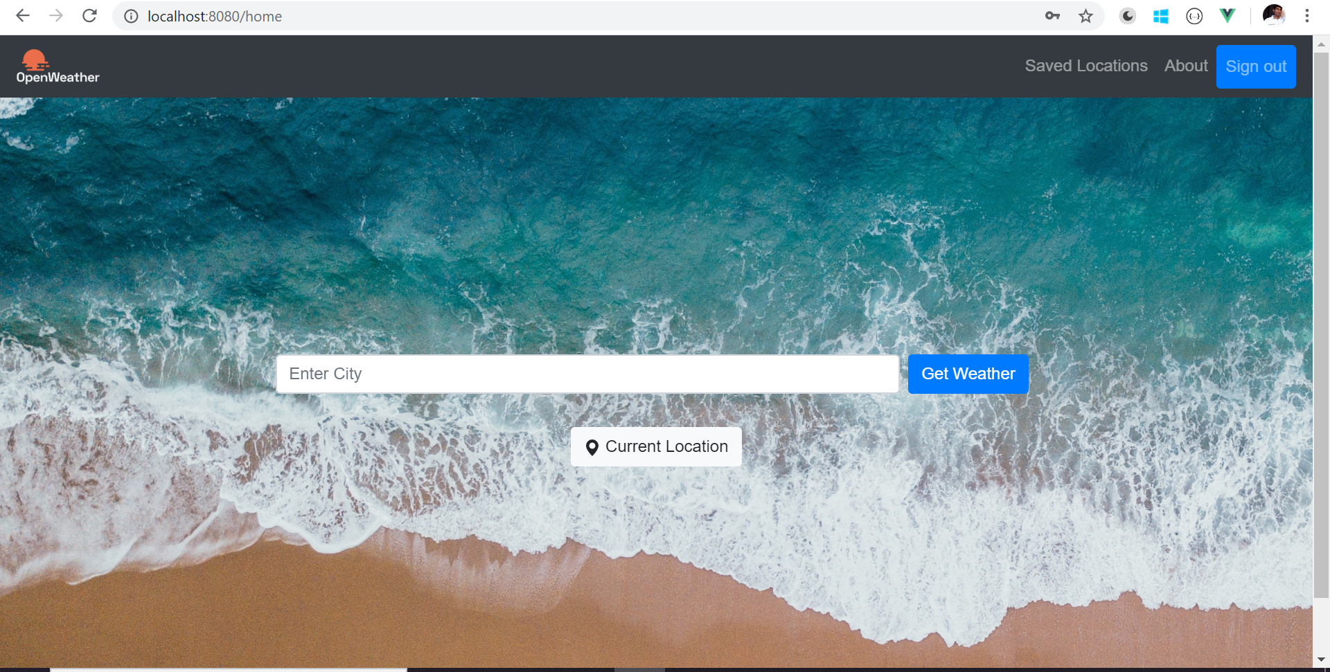

User can search different city weather and also able to save that data .

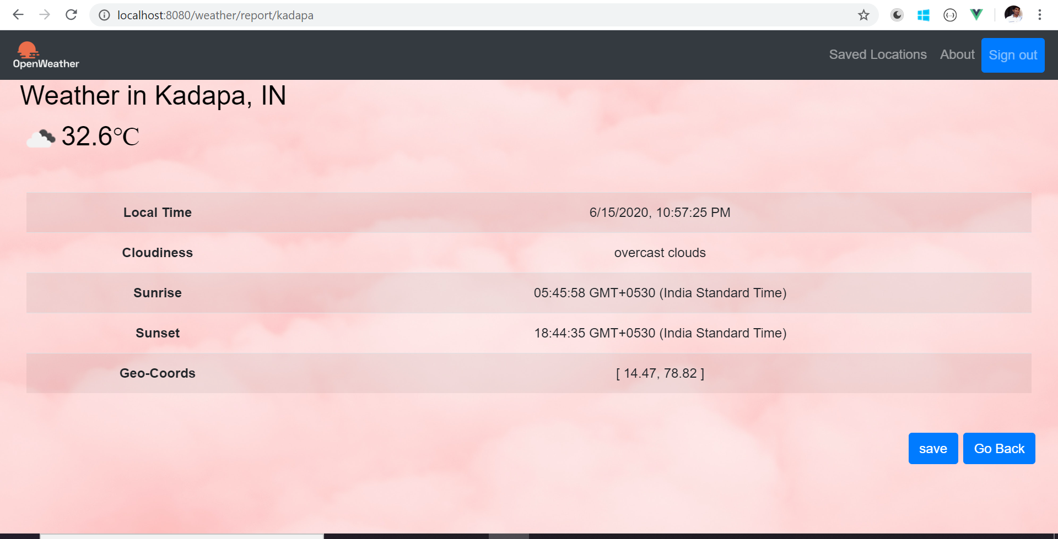

user can view saved data or delete saved locations by navigating to saved locations link in header.

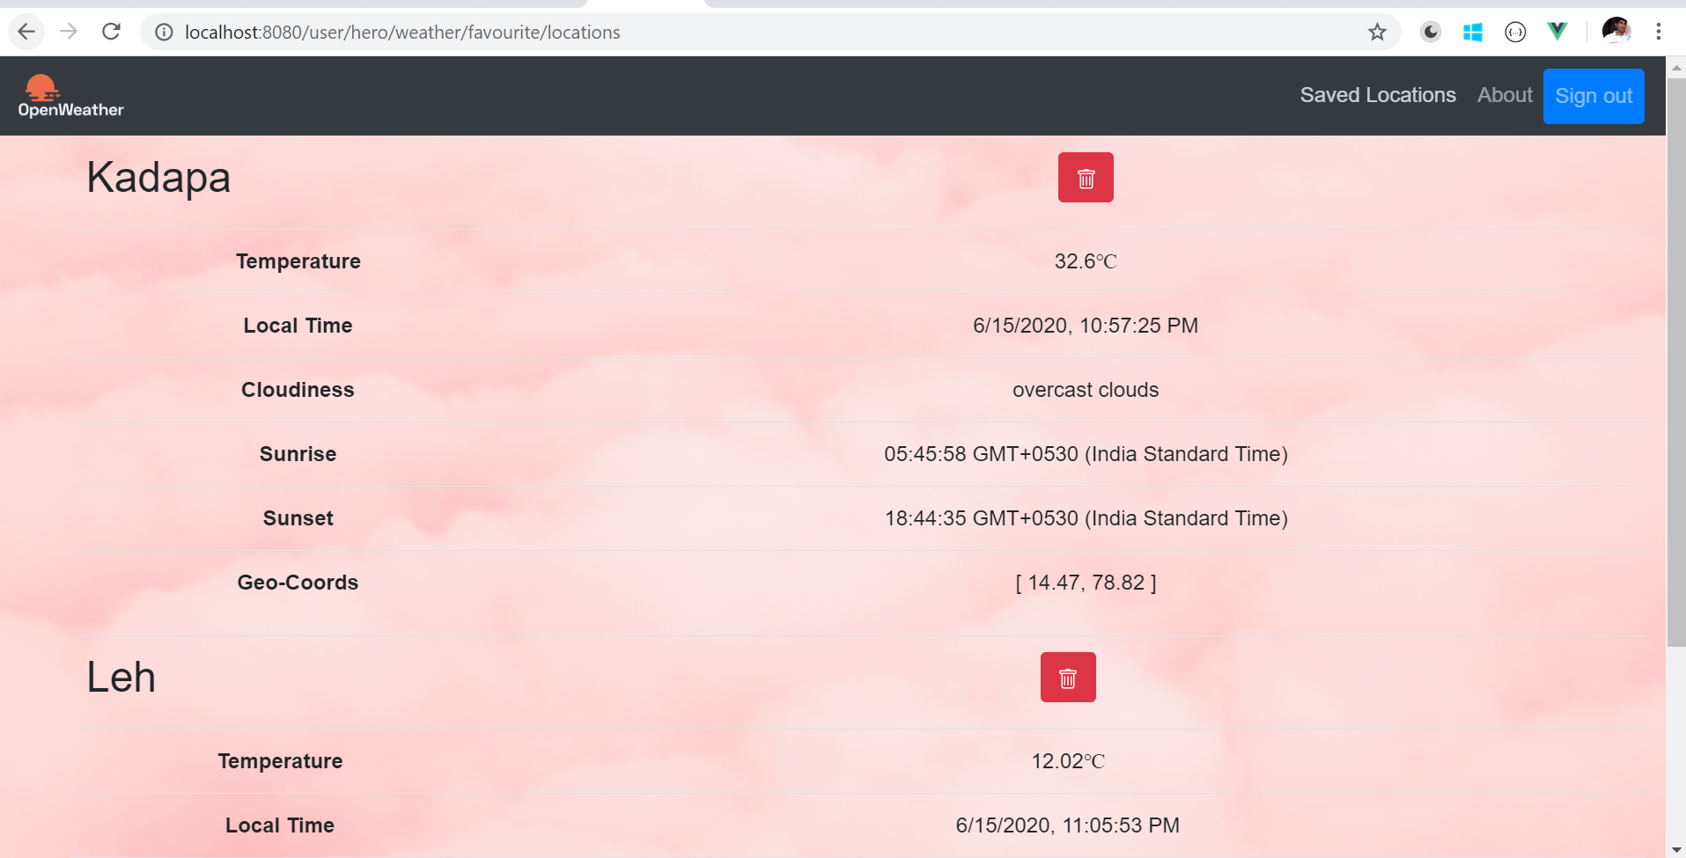

**About page :**

This is just a static page.

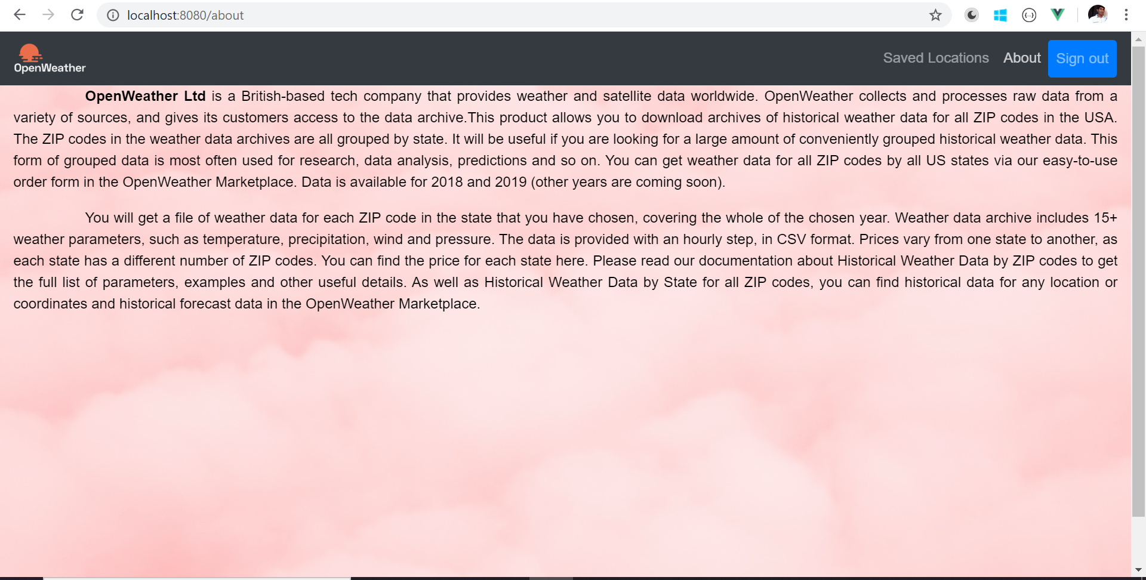

*********************************** END ***********************************